 | 12 ATAR Physics  Projectile Motion  Test 2018 T4 (5%)  Student name:

1. A boy projects a ball from a bench as shown here. Draw ALL the forces acting on the ball at the moment shown in the diagram.  Note: Make sure the forces are shown clearly on the diagram. [1] | 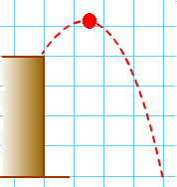

2. The family dog runs horizontally off the end of the dock at a speed of 6.70ms⁻¹ with the intention of landing in the boat that is 1.20 meters below the end of the dock. | 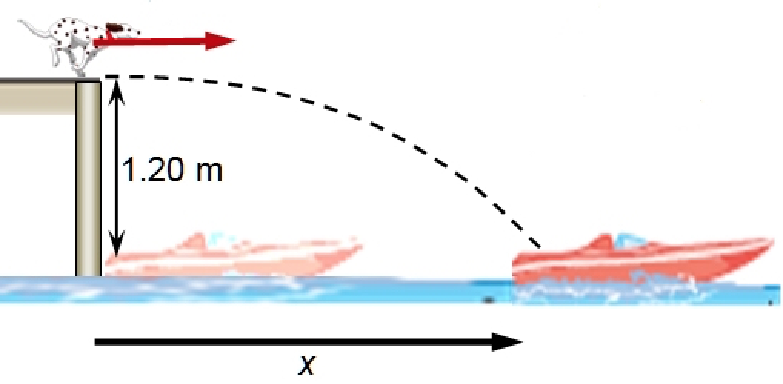

Find the maximum horizontal displacement x that the boat can be from the end of the dock without the family winding up with a wet dog. [4]

3. A football is kicked horizontally from the edge of a cliff into a river below with a speed of 10 ms⁻¹, as shown here. Calculate the velocity with which the ball enters the water. [5] | 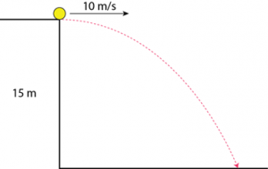

4. The picture shown below shows a stroboscopic photograph of a tennis ball moving in a parabola. The time interval (Δt) between each flash is 0.0482 sec.

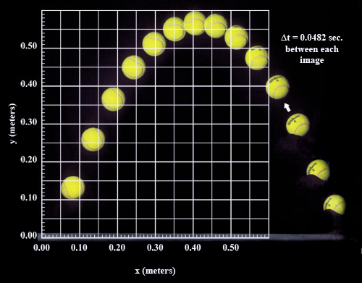

- Use the picture (previous page) to calculate the time taken for the ball to reach its maximum height. [1]

- Calculate the ball’s initial vertical speed. [1]

- Calculate the ball’s initial horizontal speed. [1]

- Draw a vector diagram of the ball’s initial motion in the space provided here. [2]

- Calculate the initial velocity of the tennis ball. [3]

5. Figure 3 shows the trajectory of a cannonball fired from a cannon.

- Neglecting air resistance, which set of vectors (shown below), represents the horizontal and vertical components of the cannonball’s velocity along the trajectory? [1]

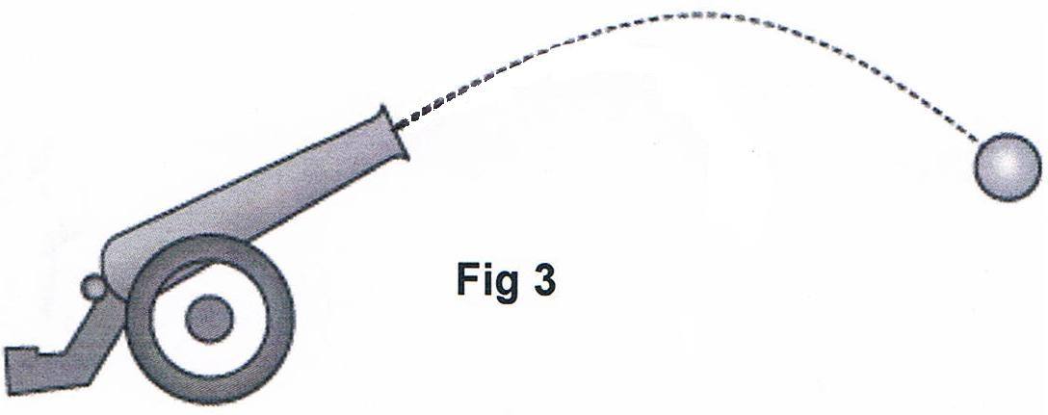

 | Horizontal plane |  |  |  | Vertical plane
A |  |  |  |  |  |  |  | 
B |  |  |  |  |  |  |  | 
C |  |  |  |  |  |  |  | 
D |  |  |  |  |  |  |  | 

6. A boy kicks a football off the edge of a cliff and into a lake with a speed of 20kmh⁻¹ and at an angle of 35º to the horizontal. The cliff is found to be 17m above the surface of the lake.

- What is the maximum height reached by the ball? [4]

- Calculate the vertical velocity of the ball as it hits the surface of the lake. [2]

- Calculate the velocity of the ball as it hits the surface of the lake. [4]

7. A 1400 kg car rounds a flat circular corner of radius 95 m.

- If the friction between the tires and the road is 7546 N, what is the maximum speed that the car can travel? [2]

This is a top view of the car in the previous question which is traveling in a counter clockwise circle.  - Draw and label clearly the direction of velocity and acceleration of the car at this point. [2] | 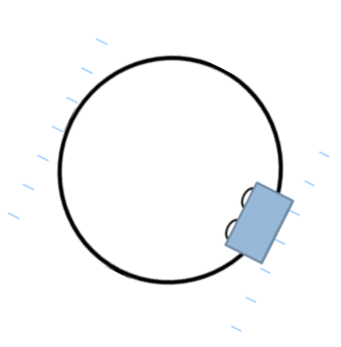

8. In 2012 the Hot-Wheels toy company executed a car stunt where a typical family car successfully performed an inverted loop on a specially designed 48 metre loop.  At the top of the loop the 500kg car is just in contact with the road. What is the minimum velocity required to keep the car in contact with the road at this point? [3] | 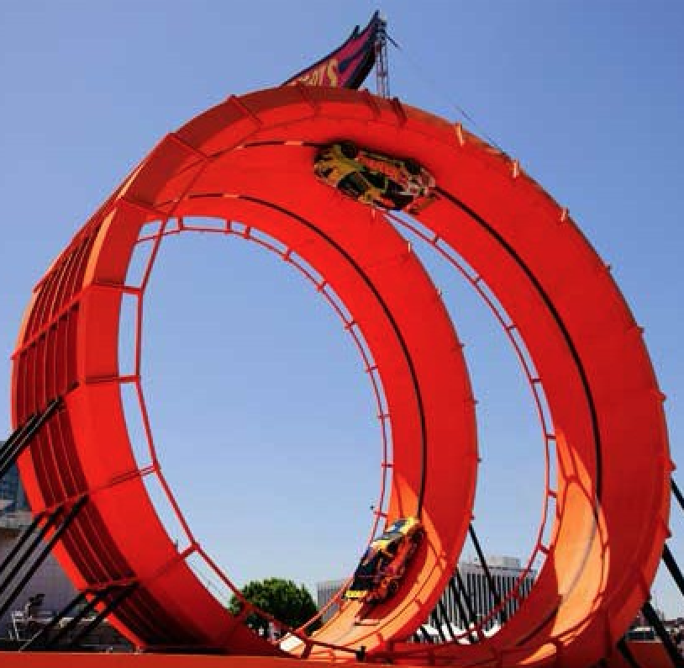

9. A cyclist is riding around a velodrome. The radius of the corner is 46.0 m. The track around the corner is banked at 50.0º. How fast must he ride so that he does not rely on friction to provide centripetal force? Include a labelled vector diagram. [3]

10. A conical pendulum consists of a small 55.0 g ball on a thin string of length 60cm.  - Calculate the tension in the string [3] | 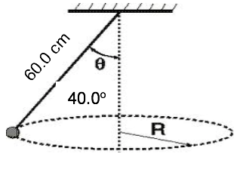

- Calculate the magnitude of the net force (centripetal) acting on the ball.
[If you did not manage to calculate the tension in part a, you can use a value of 0.800 Newtons] [2]

- How fast is the ball travelling in its circular path? [3]

